A picture containing clipart

Description generated with very high confidence

Azure 103 Module 6

Hands On - 2

Azure Certification Training

[**support@intellipaat.com**](mailto:support@intellipaat.com)

**+91-7022374614**

**US: 1-800-216-8930(Toll Free)**

**Azure 103, Module 6, Hands On - 2**

**Problem Statement: Assign a role to configure access to Azure resources.**

**Solution:**

**Step 1:** Sign into the [Azure portal](portal.azure.com) and create a resource group named rbac-RG. We will use this resource group as a scope for this role assignment.

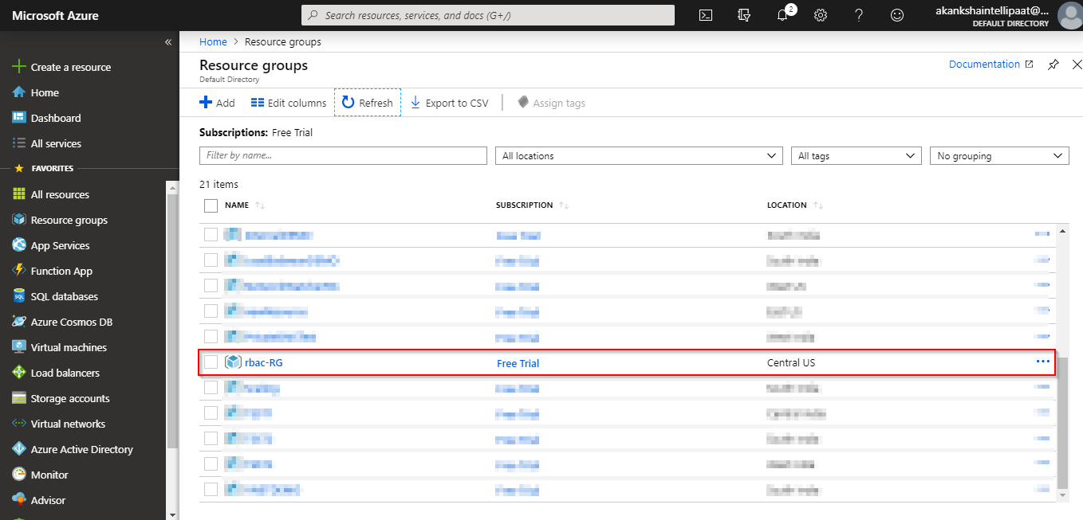

**Step 2:** Launch a basic virtual machine inside this resource group. After it is launched, go to the VM and select identity option from the left side panel.

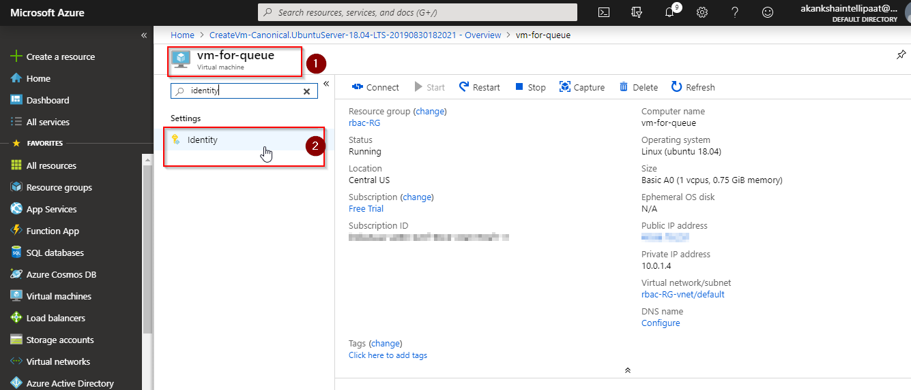

**Step 3:** In system assigned tab, switch the managed identity option to **on from off** and click on save.

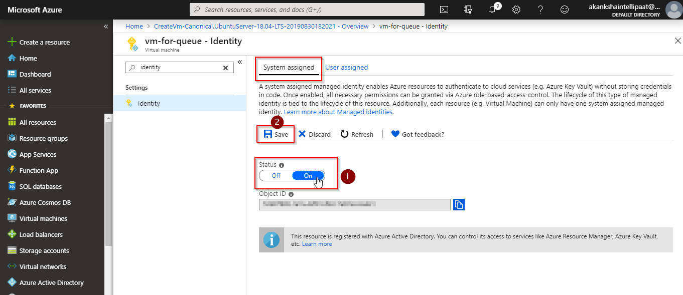

**Step 4:** Go to your resource group and select Access control (IAM) option from the left side panel, then click on role assignment tab then click on add button. Select “**Add role assignment**” option from the drop down of add button

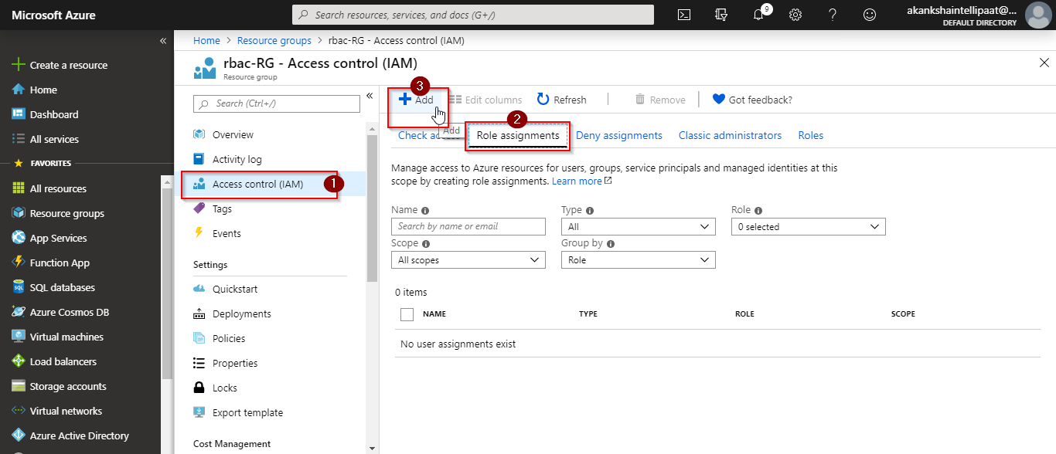

**Step 5:** In add role assignment blade tht opens up, provide the relavent information. Select a role that you want to assign. For this demo, we will choose storage Queue Data Reader role.

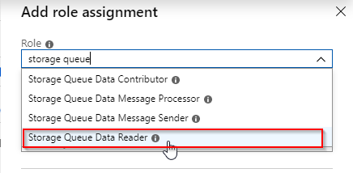

**Step 4:** For **Assign access to** field, choose Virtual Machine.

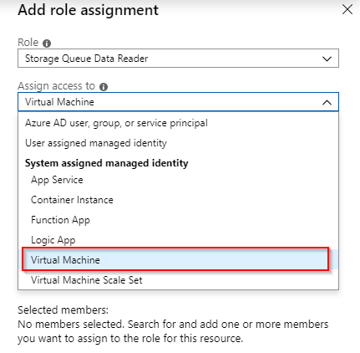

**Step 5:** As soon as you are done with the previous step, the virtual machine for which you switched on the managed identity feature will get listed below the **select field.** Click on that VM to select it.

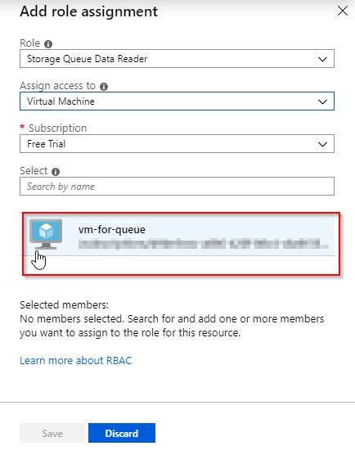

**Step 6:** Click on save to save his role assignment.

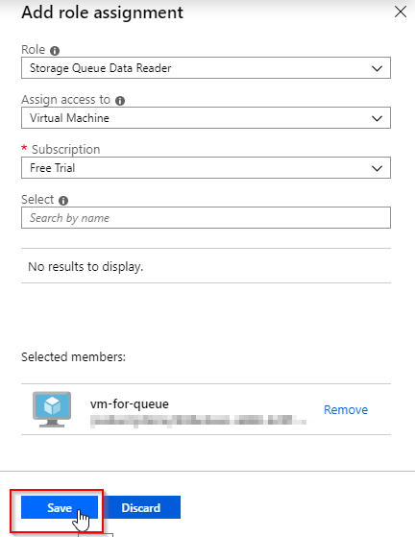

**The role assignment will be created and you will be able to see as shown in the following screenshot.**

